**Neo4J Task-2**

1. **Create Nodes:**

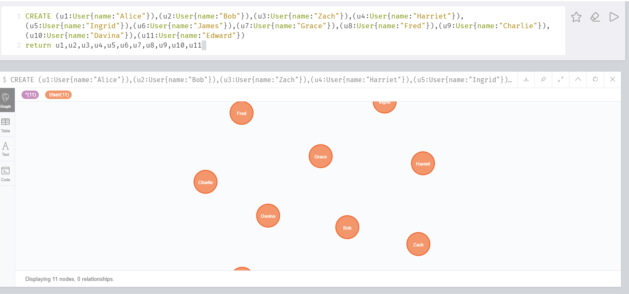

1. **Create Relationships between Node:**

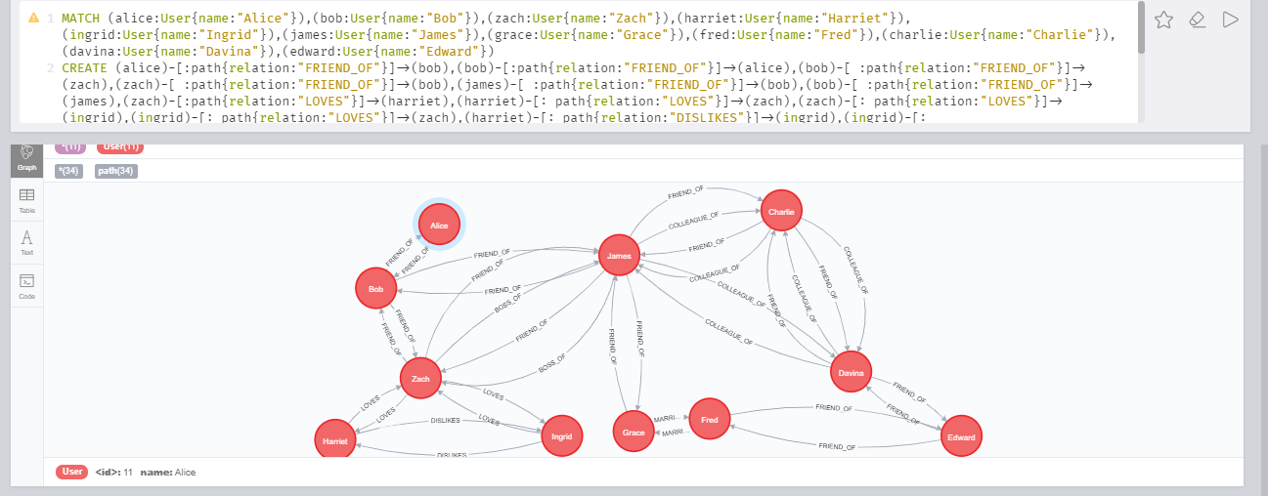

**Note:** Full Query is not visible in ScreenShot.

1. **Finding Relationships between Nodes:**

* **Two Level Relation Findings:**

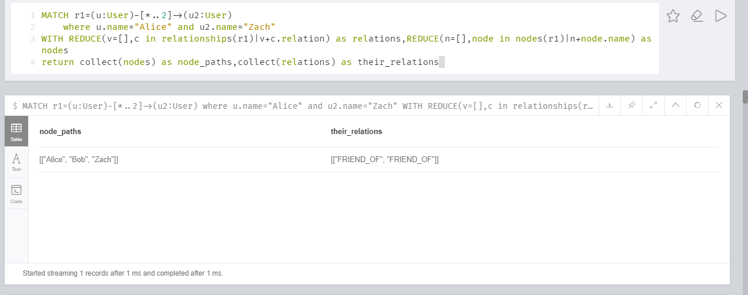

You can read it like, Alice is friend_of Bob and Bob is friend_of Zach.

* **Three Level Relation Findings:**

**Finding Relation between Alice and James**

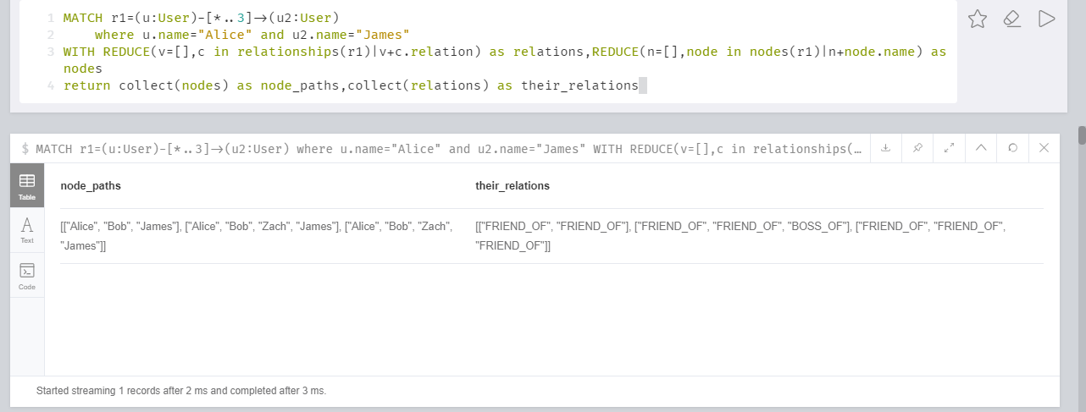

You can read it like, For **second relation** Alice->Bob->Zach->James, Alice is friend_of Bob and Bob is Friend_of Zach and Zach is Boss_of James.